C PROGRAMMING ASSIGNMENT

POINTERS

S ABHISHEK

REVERSE THE ARRAY

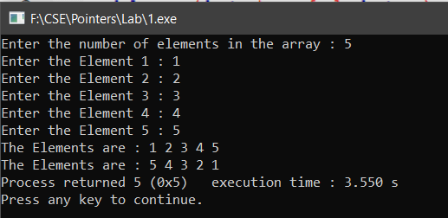

SEARCH THE ELEMENT IN THE ARRAY

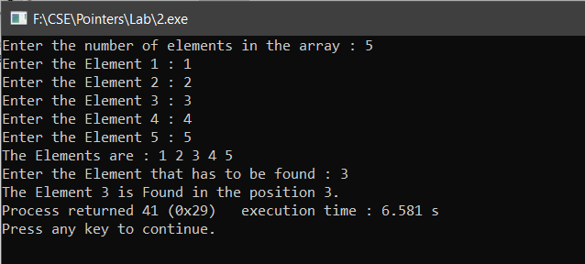

RETURN A POINTER FROM A FUNCTION AND CALCULATE THE RUNNING TIME

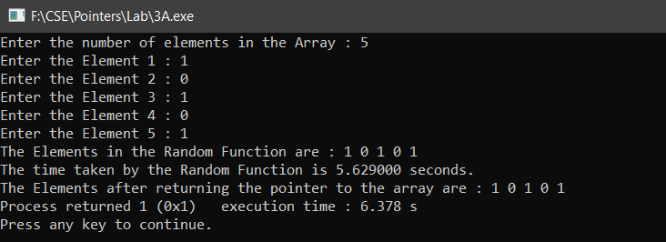

CREATE AN ARRAY AND INPUT THE ELEMENTS.

NOW CREATE A MATRIX FROM THE ROW INPUT AND NUMBER OF ELEMENTS FROM THE ARRAY.

INITIALIZE THE EMPTY ELEMENTS WITH ‘0’.

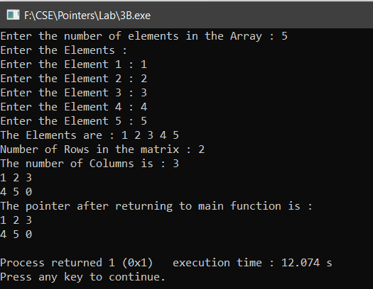

INPUT AN ARRAY AND RETURN THE POINTER THAT POINTS TO THE MAXIMUM ELEMENT IN THE ARRAY FROM THE FUNCTION AND CALCULATE THE RUNNING TIME OF THE FUNCTION

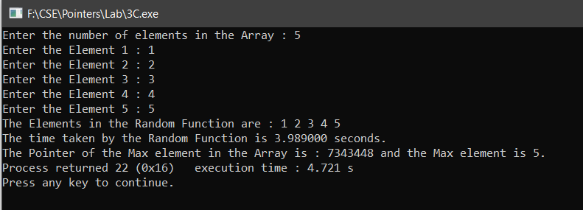

FIND THE SCALAR PRODUCT OF TWO INPUT ARRAYS USING DYNAMIC MEMORY LOCATION

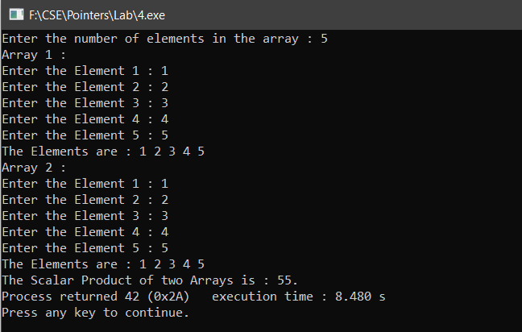

FIND THE SCALAR PRODUCT OF TWO INPUT ARRAYS USING VLA

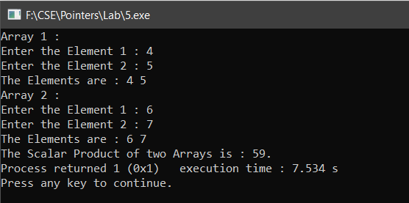

INPUT TWO ARRAYS WITH 3 ELEMENTS AND FIND THE DISTANCE BETWEEN THE TWO ARRAYS

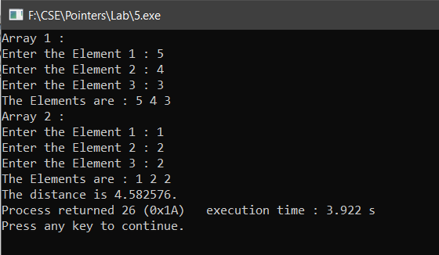

INPUT TWO UNSORTED ARRAY AND SORT THE ARRAY WHOSE LENGTH IS MINIMUM AND THEN FIND THE INTERSECTION OF THE ARRAYS

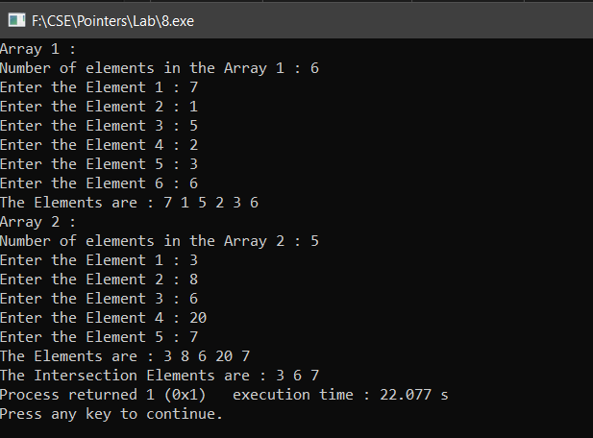

SORT THE ARRAY WITH ONLY 0,1 ELEMENTS

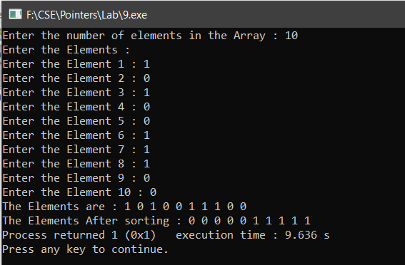

FIND THE FREQUENCY OF THE EACH CHARACTER IN THE STRING

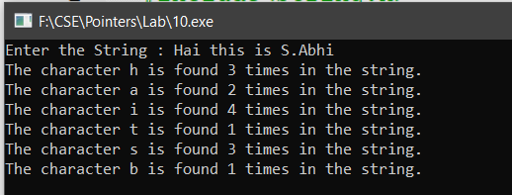

SORT THE CHARACTER ARRAY IN ASCENDING ORDER USING BUBBLE SORT

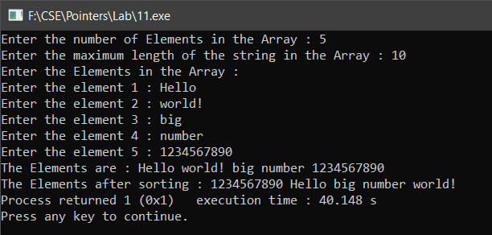

FIND WHETHER THERE IS ANY ERROR IN THE PROGRAM AND FIND THE ERROR

IF THERE IS NO ERROR FIND THE OUTPUT OF THE PROGRAM.

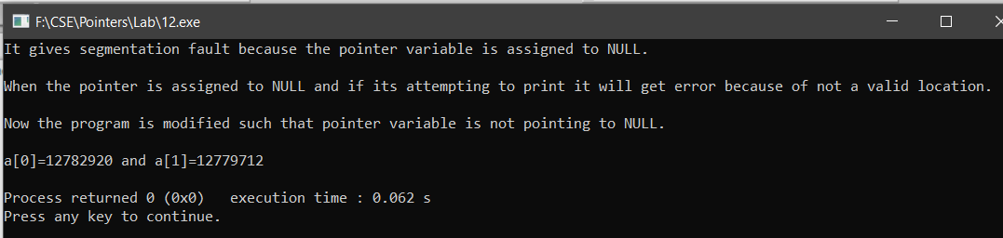

WRITE THE BASIC PROGRAM USING THE POINTERS

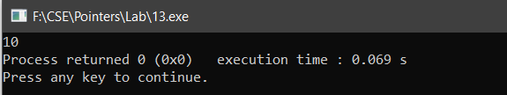

!.. THANKYOU ..!